IDB lab 2

1. Select \* from dept;

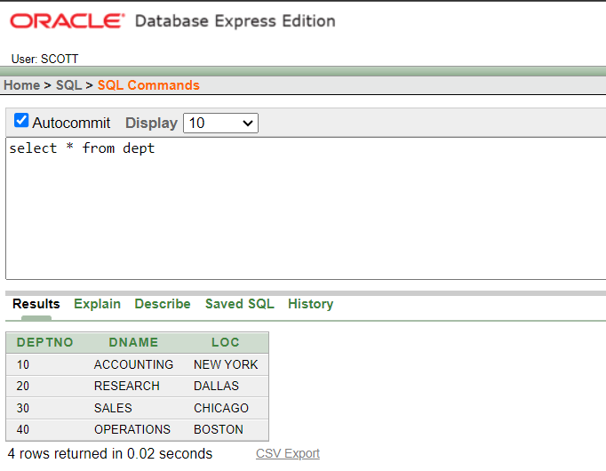

1. Select deptno, loc from dept;

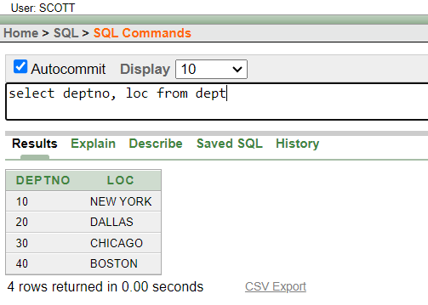

3.select ename, sal, sal+300 from emp;

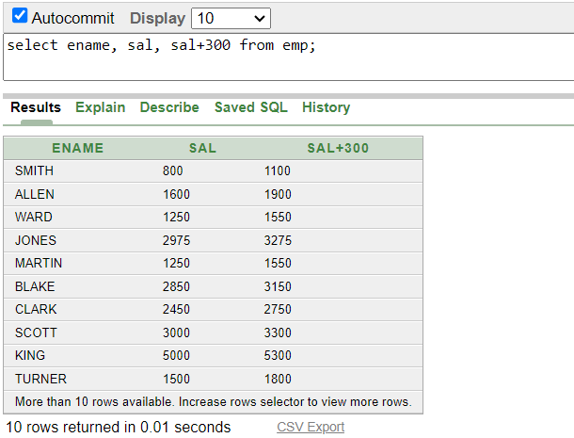

1. Select ename, sal, 12\*sal+100 from emp;

1. Select ename, sal, 12\*(sal+100) from emp;

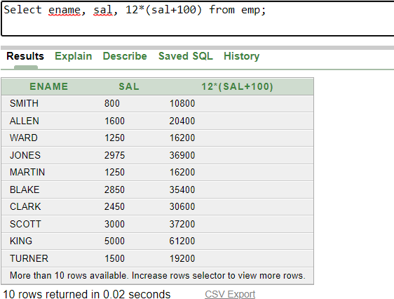

1. Select ename, job, comm from emp;

1. Select ename, 12\*sal+comm from emp;

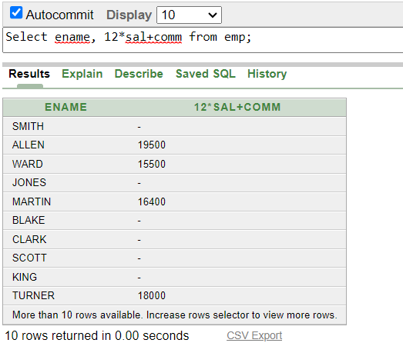

1. Select ename, 12\*sal+comm from emp where ename='MARTIN';

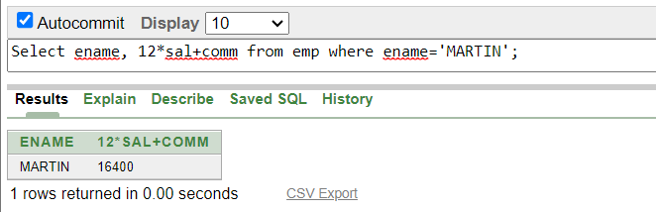

1. Select ename as name, sal salary from emp;

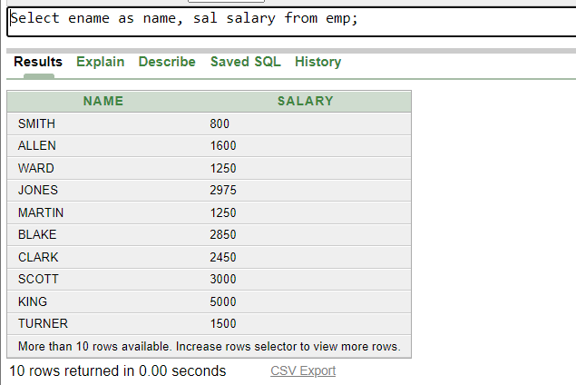

1. SELECT ename "Name", sal \* 12 "Annual Salary" FROM emp;

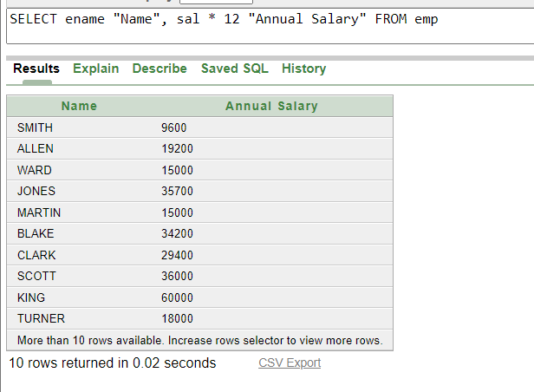

1. Select ename || job as Employees from emp;

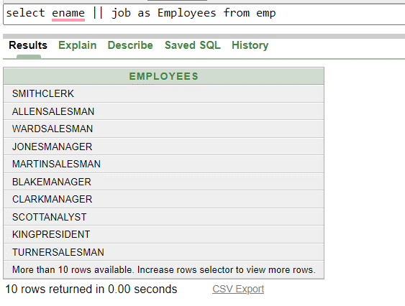

1. Select ename || ' ' || 'is a' || ' ' || job as"Employee details" from emp;

1. select deptno from emp;

1. select distinct deptno from emp;

